Test Results
Candidate Detail
Family name : Sopa-u tok
Score 70
First name : Parinya
General Evaluation
>=80 Excellent
60-79 Good
50-59 Moderate

Student ID : 58010310457
Faculty : The Faculty of Engineering
Major : Electrical Engineering
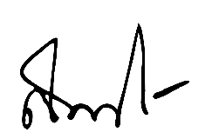
Test date : 29 March 2019
(Professor Sampan Rittidech, Ph.D.)
President of Mahasarakham University

